

AT&T Open 16 Port

G.fast DPU Specification

Revision 1.1

Authors: Thomas Anschutz, Sumithra Bhojan

# Revision History

|  |  |  |  |
| --- | --- | --- | --- |
| Revision | Date | Author | Description |
| 1.0 | 11/1/2016 | Tom Anschutz | Initial Release |
| 1.1 | 2/20/2017 | Sumithra Bhojan | Editorial updates |

# **Contents**

Revision History 2

Contents 2

Licenses 4

Scope 4

Overview 4

Indoor/Outdoor 5

Twisted Pair and Coax 5

Triplexers 6

Reverse Power 6

Software Stack 6

G.fast Network Application 7

Physical Overview 9

Maximum Dimensions 9

Top View 9

Front View 9

Panel LED Definitions 9

SFP+ Interface Module support 10

Rear View 10

Wiring Adaptation Modules 10

Twisted Pair Module 10

Twisted Pair Module with reverse power feed 10

Coax Module 10

Coax Module with Triplexers 11

System Overview 11

Main Block Diagram 11

Functional Hardware Blocks 12

Software Support 13

BMC support 13

ONIE (Optional CPU Module) 13

Open Network Linux 13

Overall System Software 13

General Specifications 14

Power Consumption 14

Specification Requirements 15

Safety 15

Electromagnetic Compatibility 15

ROHS 15

# Licenses

All devices that may be referred to in this specification, or required to manufacture products described in this specification, will be considered referenced only, and no intellectual property rights embodied in or covering such devices shall be licensed as a result of this specification or such references. Notwithstanding anything to the contrary in the Open Compute Project Contributor License Agreement or the Open Web Foundation Final Specification Agreement (OWFa 1.0), the licenses set forth therein do not apply to the intellectual property rights included in or related to the devices identified in this specification. For clarity, no patent claim that reads on such semiconductor devices will be considered a “Granted Claim” under the applicable Open Web Foundation Final Specification Agreement (OWFa 1.0) for this specification.

To the extent of AT&T’s authorship in this specification, AT&T submits this specification to the Open Compute Project Foundation as a Contribution under the Open Compute Project Contributor License Agreement (July 13, 2014 version, available at the time of this writing, March 4, 2016, at <https://rightsignature.com/forms/OMMUS-72474399-v1-db5554/token/27cfcf4a00d>. AT&T agrees to make such specification available under the Open Web Foundation Final Specification Agreement (OWFa 1.0), which is available at <http://www.openwebfoundation.org/legal/the-owf-1-0-agreements/owfa-1-0>.

Your use of this specification may be subject to other third party rights. THIS SPECIFICATION IS PROVIDED "AS IS." No support of any kind will be provided by the contributors. The contributors expressly disclaim any warranties (express, implied, or otherwise), including implied warranties of merchantability, non-infringement, fitness for a particular purpose, completeness or title, related to the specification. The entire risk as to implementing or otherwise using the specification is assumed by the specification implementer and user. IN NO EVENT WILL ANY PARTY BE LIABLE TO ANY OTHER PARTY FOR LOST PROFITS OR ANY FORM OF INDIRECT, SPECIAL, INCIDENTAL, OR CONSEQUENTIAL DAMAGES OF ANY C H A R A C T E R FROM ANY CAUSES OF ACTION OF ANY KIND WITH RESPECT TO THIS SPECIFICATION OR ITS GOVERNING AGREEMENT, WHETHER BASED ON BREACH OF CONTRACT, TORT (INCLUDING NEGLIGENCE), OR OTHERWISE, AND WHETHER OR NOT THE OTHER PARTY HAS BEEN ADVISED OF THE POSSIBILITY OF SUCH DAMAGE.

# Scope

This document defines the technical specifications for the AT&T Open 16-Port G.fast DPU submitted to the Open Compute Project.

# Overview

This document describes the technical specifications of the AT&T Open 16-Port G.fast Distribution Point Unit (ODPU). The system is a physical unit that is self‐contained, and not part of a rack or other physical chassis system. The system is typically deployed in outside plant or in telco closets in multi-dwelling units. The Open 16-Port G.fast DPU is a high-performance access design focused on broadband deployments that support both symmetric and asymmetric speeds with a total bandwidth per port up to 1Gbps. The ODPU is fed using an optical uplink, attached via SFP and supporting both Ethernet and PON technologies with Speeds up to 10Gbps.

The ODPU supports 16 customer-facing G.fast ports that can be adapted to either twisted pair or coax cables and a single 10Gb upstream SFP+ port.

The Open 16-Port G.fast DPU also allows for power to be supplied by one or more of its customer-facing ports, called reverse power feed, and thus allows the unit to be placed in locations where power is not available. This silicon used in the ODPU provides high throughput at low cost, latency, and power.

Applications of this design include some specific variations and considerations in order to address a broader market and set of collaborators for this project. Specifically, the set of variations considered include:

1. Deployment both indoors and outdoors
2. Use of twisted pair or coax wiring to the customers
3. Including triplexers to combine other video signals on the coax lines
4. Including reverse power feed

The four variations are not mutually exclusive, and are now described in more detail.

# Indoor/Outdoor

The first variation is largely in packaging for the AT&T Open 16-Port G.fast DPU. Two packaging options are provided for the system.

The first in an indoor package, designed for deployment in basements, or telco closets in typical MDU locations. This package emphasizes ease of access and modularity of the physical serving interfaces.

**Figure 1 – Indoor ODPU**

The second package is an outdoor enclosure, designed for deployment in pedestals, poles, and underground enclosures. This package emphasizes robust weather resistance and environmental robustness.

**Figure 2 – Outdoor ODPU**

# Twisted Pair and Coax

This variation for the AT&T Open 16-Port G.fast DPU supports different wiring from the ODPU to the customer modem or residential gateway. The first option is twisted pair, and the second is coax. Although the wiring type differs, the signal and electrical properties are nearly identical, with a simple balun (**Figure 3**) allowing adapting one or the other – or allowing interworking in the wiring system.

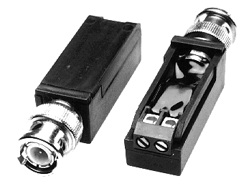 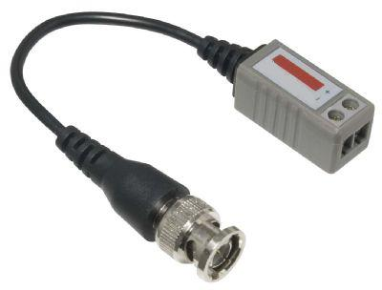

**Figure 3 – Balun Examples (added)**

Because so much of the ODPU remains unchanged between these options, the design chooses to make the wire termination a modular component of the design, allowing a single ODPU SKU to serve both applications by attaching either a twisted pair or coax module.

# Triplexers

In some applications where coax cables are used, there is a desire to deliver both broadband data as well as video from satellite or cable systems. This is accomplished by including triplexers on the coax module for the ODPU. Video signals are attached to the triplexers and delivered in concert with the broadband data.

# Reverse Power

Reverse power feed is one of various ODPU powering methods defined in TR-301. Here, the ODPU draws its power from the customer premises via the copper lines between those premises and the ODPU. The reverse power feed capacity and ODPU power consumption need to be such that the ODPU can be fully operational when only a single customer is connected. Any back-up battery would be located in the customer premises. Reverse powering shall have two power splitters (one located at the customer premises and another at the remote node-ODPU) to enable power to be inserted at the customer end of a link and extracted at the remote node-ODPU. Within the remote node -ODPU, if it operates with multiple power-fed lines then there shall be a power extraction and combiner unit. The purpose of this unit is to combine the multiple power feed inputs to produce a single power source output. The power load should be shared amongst the input power sources.

# Software Stack

Software to drive the AT&T Open 16-Port G.fast DPU is based on same approach taken for the Open GPON and XGS-PON specs. As shown in Figure 4, and moving from the bottom to the top of the figure, the ODPU has Firmware and a Driver that runs in the silicon and provides a management interface toward a standard management agent called a Persistent Management Agent (PMA). A PMA manages a single ODPU and there is a PMA Aggregator (PMAA) that manages many. In the software stack, we will develop an open scale-out PMA with aggregation included. The ON.Lab VOLTHA project is an open multi-protocol management and control plane agent, and will be used to derive OpenFlow, as well as NETCONF/YANG interfaces to the control plane applications and configuration controllers. From these interfaces upwards, the same applications are used that were developed for GPON and XGS-PON in order to configure and control the G.fast system as part of an access network. This re-use of the networking stack is intentional because GPON and XGS-PON are both popular backhaul technologies for G.fast ODPUs.

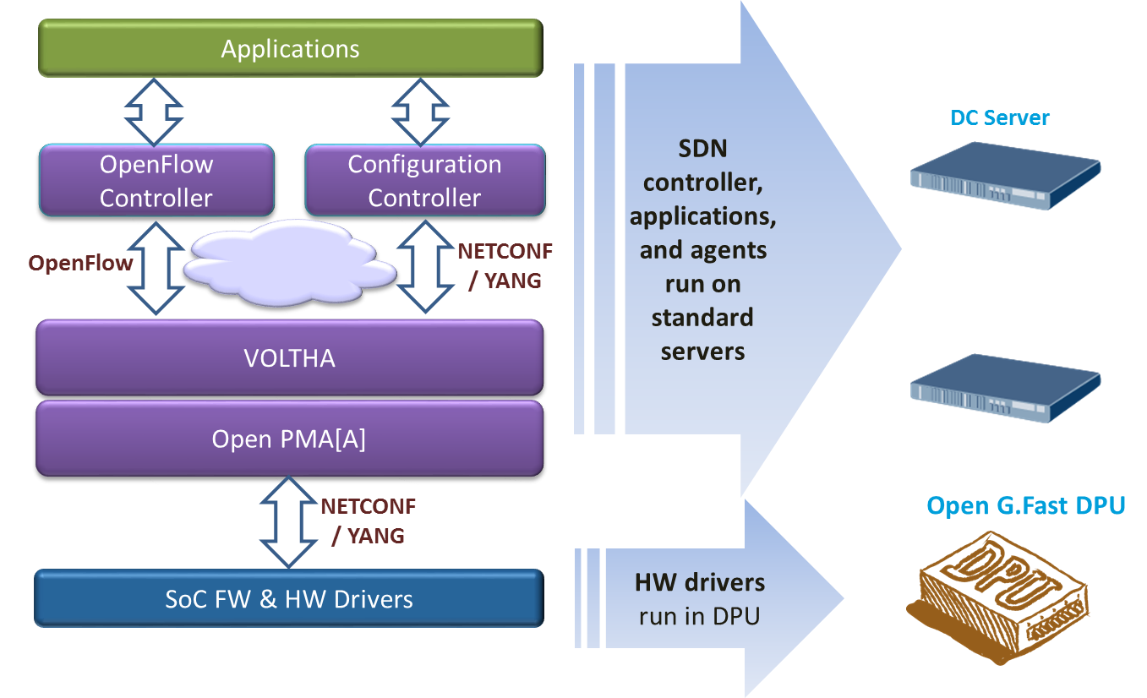

Figure 4 - Software stack for Open 16-Port G.fast DPU

To support this application, the Open 16-Port G.fast DPU minimizes the number of components populated on the system board and leverages external, scalable, available and re‐usable components instead.

This is the most basic and economic instantiation of this design. Management is performed through external processes and is communicated through a virtual LAN that isolates that traffic from customer traffic. Specifically, there is a need to support OOB (out of band management) LAN. The design does still support a variety of power supply options, airflow options, and a baseboard management controller (BMC) to manage these resources.

# G.fast Network Application

A G.fast Access network supports customers of various types, including both single and multi-family dwelling units, and including options for one or more customers per ODPU and multiple ODPUs per location. A novel and key feature of G.fast is the ability to reverse-power the ODPU from one or more attached customer ports. This allows placing ODPUs on poles or at the curb where powering is difficult.

Some key features include:

Figure 5 shows G.fast Access technology, which is typically deployed in twisted pair or coax loops that are less than 500m, and which support about a gigabit of bandwidth when both directions are added up. The split of bandwidth used for upstream and downstream is configurable, and can be symmetric (e.g. 500x500M) or can be asymmetric (e.g. 750Mx250M). G.fast can be deployed in various configurations, some of which are shown in Figure 6.

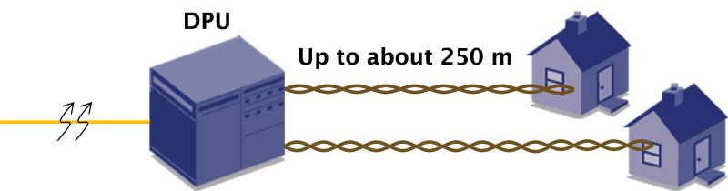

Figure 5 – G.fast Access Technology

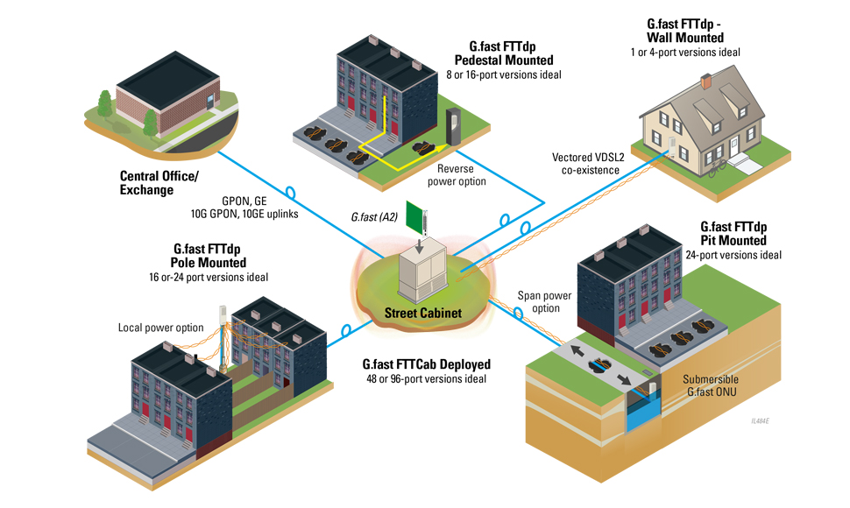

Figure 6 – G.fast Access Network

# Physical Overview

## Maximum Dimensions

|  |  |  |
| --- | --- | --- |
|  | Inches | Millimeters |
| Length - |  |  |
| Width – |  |  |
| Height – |  |  |
|  | | |

## Top View

The top view of the Open 16-Port G.fast DPU shows the PCBs and associated components in the system (illustrative only).

5

## 

## Front View

The front view of the Open 16-Port G.fast DPU shows the external connectors and associated components in the system (illustrative only).

2

1

## Panel LED Definitions

|  |  |  |
| --- | --- | --- |
| LED Name | Description | State |
| Diag | LED to indicate system diagnostic test results | Green – Normal  Amber – Initializing  Red – Fault detected  Off – Powered down |
| SFP+ Speed LED | LED built into  SFP+ cage to indicate port speed | Green 3 blinks/pause – 10G  Green 2 blinks/pause – 2.5G  Green 1 blink/pause – 1G  Off – No Link/Port down |
| SFP+ Enable LED | LED built into  SFP+ cage to indicate SFP status | On Green – SFP installed and active Flashing indicates activity  On Amber– SFP installed, but has a fault  Off – No SFP installed or Administered down |
| G.fast | 16 LEDs to indicate G.fast port status | Green – Normal  Amber – Initializing  Red – Fault detected  Off – No Link/Port down |

### SFP+ Interface Module support

|  |  |
| --- | --- |
| 10Gb XGS-PON XFP Modules | Standard 10Gb XGS-PON XFP modules |

## Rear View

The rear view of the Open 16-Port G.fast DPU includes the following key components:

## Wiring Adaptation Modules

Wiring adaptation modules are connected to the ODPU using a common connector. The connector is an XXXXX

|  |  |  |
| --- | --- | --- |
| Signal Name | Pin Number | Description |
|  |  |  |
|  |  |  |

**Table 1 Wiring Adaptation Module Signals Definition**

### Twisted Pair Module

This module supports attachment of twisted pair wiring to the ODPU.

Figure 7 – Twisted Pair Module

### Twisted Pair Module with reverse power feed

This module supports attachment of twisted pair wiring to the ODPU and also provides for powering the ODPU from one or more access ports.

Figure 8 – Twisted Pair Module with Reverse Power

### Coax Module

This module supports attachment of coaxial cable wiring to the ODPU.

Figure 9 – Coax Module

### Coax Module with Triplexers

This module supports attachment of coaxial cable wiring to the ODPU and also includes triplexers to allow combining G.fast signals with video signals on the serving cable.

Figure 10 – Coax Module with Triplexers

# System Overview

## Main Block Diagram

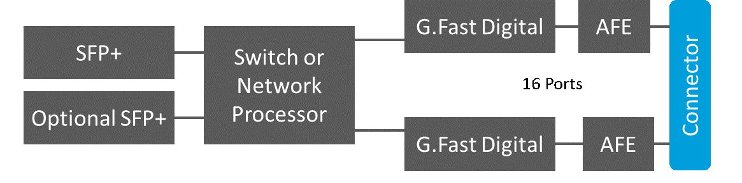

Figure 11 - Main system Block diagram

The block diagram in Figure 11 shows the high level block diagram of the ODPU.

* One SFP+ and an optional second SFP+ for backhaul and or daisy chaining.
* A Switch + Processor, or combo device to aggregate the traffic and host the management software.
* Several DFE ASICs as needed to support 16 ports of G.fast
* Several Analog Front End (AFE) chips as needed to support 16 ports of G.fast
* A common connector to support several media options – shown in Figure 12

The G.fast modem is comprised of two primary components, the DFE and the AFE.

**DFE** – The Digital Front End (DFE) is the heart of the modem, and is responsible for all of the signal processing and “baseband” type functions, up to and including the Ethernet interface to the uplink.

**AFE** – The Analog Front End (AFE) is digitally coupled to the DFE, and is primarily responsible for converting the digital signals from the DFE into electrical waveforms that are emitted by the ODPU onto the transmission media, as well as receiving electrical waveforms from the transmission media, converting them into their digital analogs, and sending them to the DFE for decoding.

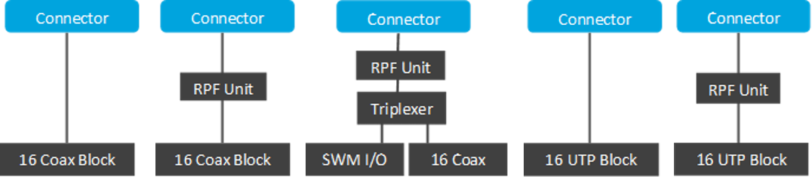

Figure 12 - Wiring Adaptation Module diagram

Figure 12 shows the Wiring adaptation module connected to an ODPU via a common connector to support several media options

* Coax Module
* Coax module with triplexers
* Coax module with triplexers and reverse power feed
* Twisted pair module
* Twisted pair module with reverse power feed

#### Supporting different Uplink connectivity modes

The Open 16-Port G.fast DPU uplink connectivity and configuration architecture can support various uplink link modes which can be configured differently based on the required bandwidth (e.g. 1G, 2.5G or 10G). There is also an option for a second uplink port. For example -

* For **1G** – A 1G Ethernet SFP or PON ONT operating at 1G
* For **2.5G** – Typically a GPON SFP ONT
* For **10G** – A 10G Ethernet SFP+ or PON ONT operating at 10G

The optional second SFP+ port is intended as a general purpose port. It can be used as redundant or auxiliary backhaul, or as a daisy chain to a second DPU, or as a local access port.

# Functional Hardware Blocks

# Software Support

The Open 16-Port G.fast DPU supports a base software package composed of the following components:

### BMC support

OpenBMC Is there a desire for IPMI or a true BMC?

### ONIE (Optional CPU Module)

Initialization and firmware updates

### Open Network Linux

See <http://opennetlinux.org/>for latest supported version (Is this feasible and appropriate?)

### Overall System Software

See <http://opencord.org/> for information and documentation

See <https://github.com/opencord/cord> for software source

# General Specifications

## Power Consumption

The total estimated system power consumption of the AT&T Open 16-Port G.fast DPU is targeted to be less than ~35 Watts. This is based upon worst case power assumptions for traffic, optics used, and environmental conditions.

|  |  |  |  |  |  |
| --- | --- | --- | --- | --- | --- |
| Main Blocks | Qnt. | Typ. (W) | Max. (W) | Total Typ. (W) | Total Max. (W) |
|  |  |  |  |  |  |
|  |  |  |  |  |  |
|  |  |  |  |  |  |
|  |  |  |  |  |  |
|  |  |  |  |  |  |
|  |  |  |  |  |  |
|  |  |  |  |  |  |
|  |  |  |  |  |  |
|  |  |  |  |  |  |
|  |  |  |  |  |  |
|  |  |  |  |  |  |
| Total estimated Power |  |  |  |  |  |

# Specification Requirements

Environmental placement requirements differ for the outdoors and indoors units.

## Safety

* UL/ Canada
* CB (Issued by TUV/RH)
* China CCC

## Electromagnetic Compatibility

* GR-1089-CORE
* FCC Title 47, Part 15, Subpart B Class A

## ROHS

Restriction of Hazardous Substances (6/6)

Compliance with Environmental procedure 020499-00 primarily focused on Restriction of Hazardous Substances (ROHS Directive 2002/95/EC) and Waste and Electrical and Electronic Equipment (WEEE Directive 2002/96/EC)